Chapel Street Surgery

Practice Information Leaflet

93 Chapel Street , Billericay , Essex, CM12 9LR
Dr Reshma Rasheed – GP Principal
Dr A C Williams – Salaried GP
Dr T Gupta – Salaried GP
Dr S Jain - Locum
Dr A Davies - Locum
Telephone Number: 01277 315815
Website: www.chapelstreetsurgery.co.uk
Email: chapel.street93@nhs.net
Opening times:
Monday – Friday 7:00 – 18:30
Phone lines open from 8:00 -18:30
*We are closed on the first Tuesday afternoon each month for training

We are taking new patient registrations, please find below our catchment area map:
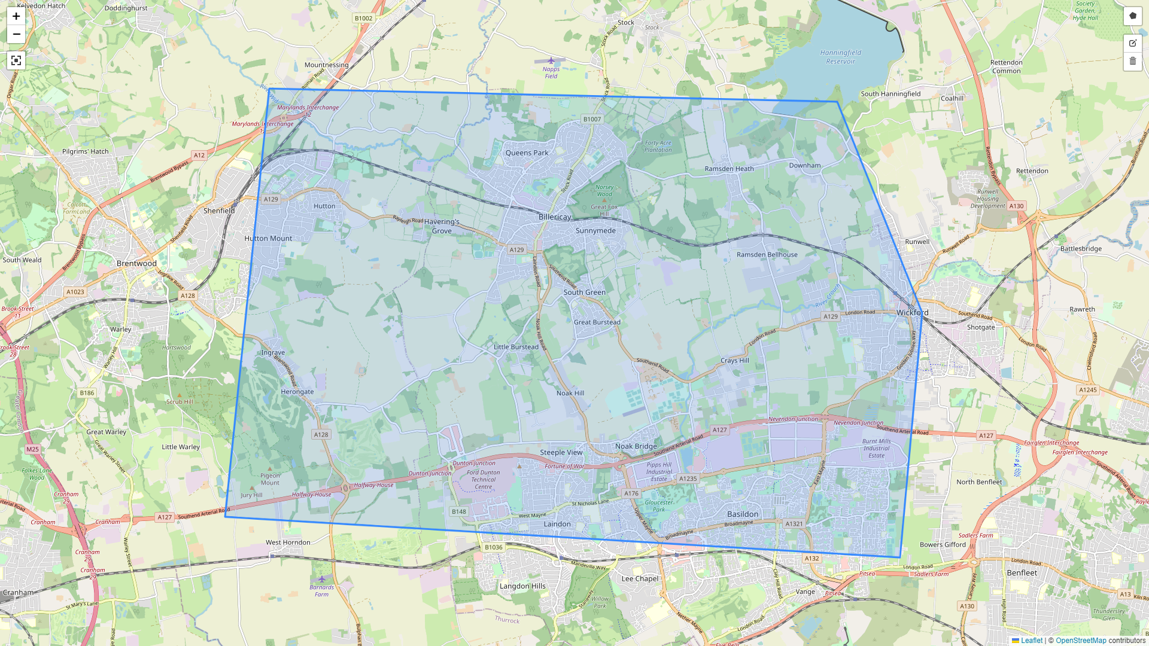
Booking an appointment is now quick and easy, just go to our website: https://www.chapelstreetsurgery.co.uk and choose between the two options available.

Clinics and Services
We offer a range of services including antenatal care, travel advice and immunisations, health promotion, chronic disease management etc.
Complaints can me made verbally or in writing addressed to the Practice Manager Judit Horvath.
Please note that our practice operates on a Zero Tolerance Policy, people who are abusive may be asked to leave and could be removed from our patient list.

